**SEMIE III H. CAPALES**

Address: Navarro street, Galvez Building House, Taft (Pob.), Surigao City

Mobile#: 0930-607-07377

***PERSONAL DATA:***

Age : 19

Date of Birth : March 30, 2004

Place of Birth : Palanit, San Isidro Northern Samar

Civil Status : Single

Height : 5’4

Weight : 55 kgs.

Sex : Male

Religion : Roman Catholic

Nationality : Filipino

Mother’s Name : Menda L. Hapa

Father’s Name : Seme C. Capales Jr.

***EDUCATIONAL BACKGROUND:***

Vocational : Surigao Del Norte State University

COURSE. : **BS-ComSci**

Secondary : Don Ruben Edera Ecleo Senior Memorial National

Highschool

STRAND : **HUMSS**

Elementary : San Pascual Elementary School

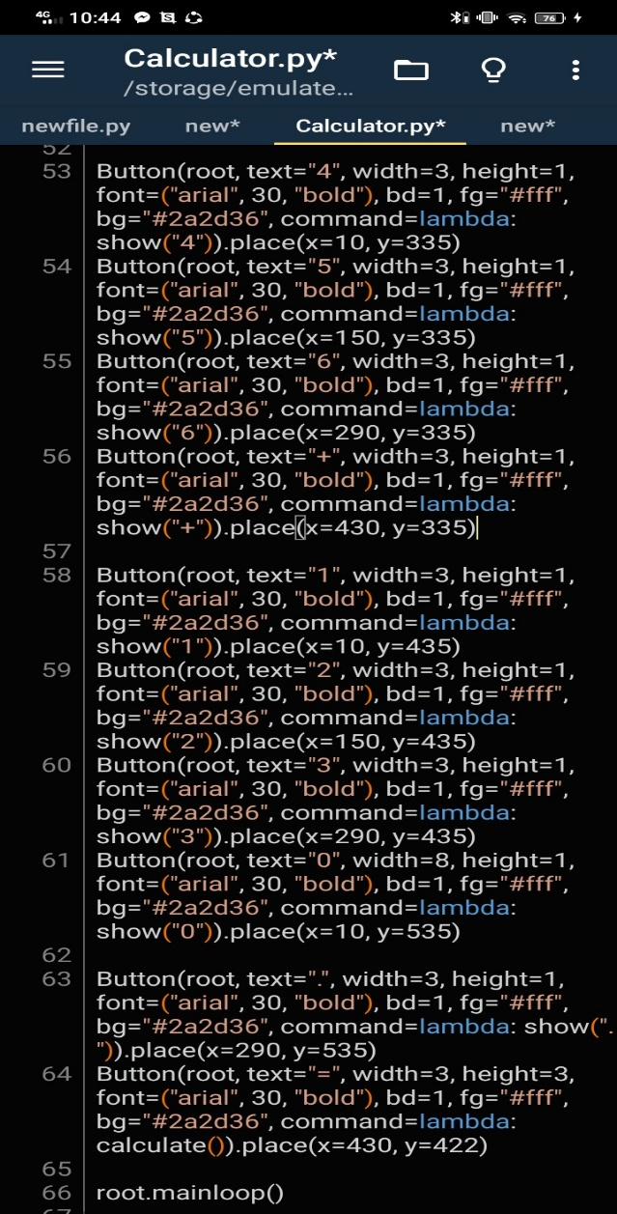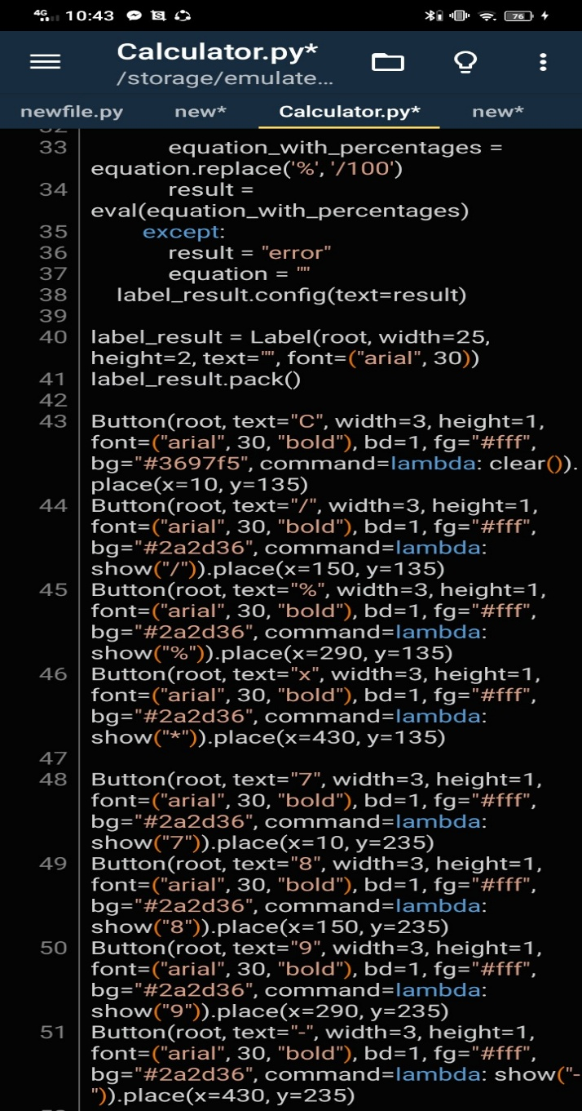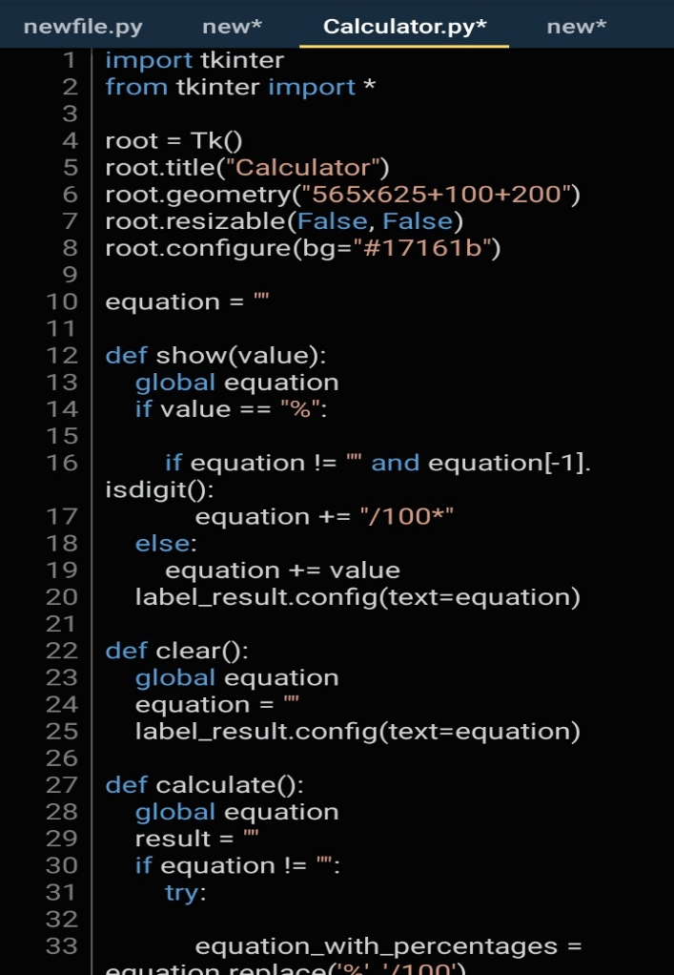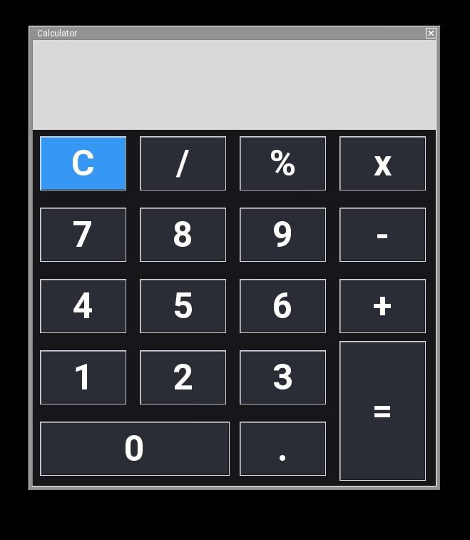

**OUTPUT**

**INPUT**

**Description of your study**

The title “GUI Calculator” is about a simple GUI calculator program designed to perform basic mathematical calculations.

**Benefits of your code**

My code provides numerous benefits that can enhance our daily lives. It provides a convenient solution for conducting quick calculations, making tasks such as budgeting, expense tracking, and basic math operations more accessible and efficient. Additionally, its accessible, being written in Python language, it can run on various devices equipped with Python, including computers, smartphones, and tablets.

**Objectives**

This code aims to develop a basic calculator interface using Tkinter in Python, enabling basic arithmetic operations like addition, subtraction, multiplication, and division. This code is also designed and open for possible enhancement and upgrades.

**Purpose of your code**

The purpose of this code is to create a functional calculator with a graphical user interface (GUI) using the Tkinter library in Python. The calculator allows users to perform basic arithmetic operations, including addition, subtraction, multiplication, and division, as well as calculate percentages. Overall, the purpose is to offer users a versatile and user-friendly tool for performing mathematical calculations efficiently.

**Significance of your code**

By creating a graphical user interface calculator using Tkinter, it can offers accessibility to users across various platforms, enhancing convenience and efficiency in tasks requiring basic arithmetic operations. The percentage functionality and error handling mechanisms ensures versatility and accuracy in calculations. Furthermore, the code contributes in simplifying mathematical tasks, promoting learning, and facilitating problem-solving in everyday life, education, and professional settings.

**Features of your code**

The features of this code include:

1.)**Graphical User Interface (GUI)**: Utilizes Tkinter library to create an interactive GUI for the calculator.

2.)**Basic Arithmetic Operations**: Supports addition, subtraction, multiplication, and division.

3.)**Percentage Calculation**: Includes a “%” button to calculate percentages of numbers entered.

4.)**Error Handling**: Implements try-except blocks to catch and handle errors that may occur during evaluation, displaying “error” if calculation fails.

5.)**Customization**: Enables users to customize the appearance of the calculator interface, including button size, font, and colors.

6.)**Clear Functionality**: Provides a “C” button to clear the input and reset the calculator.